Build OPENCV for CUDA in Ubuntu:

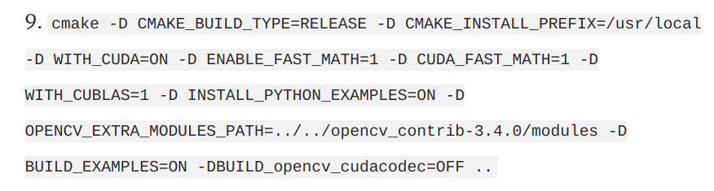

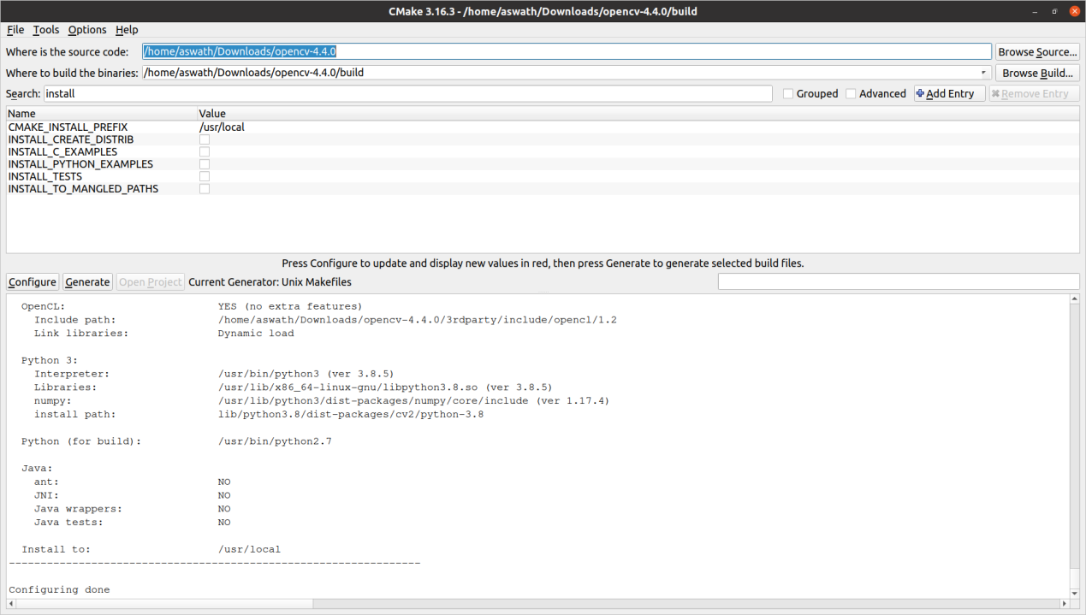

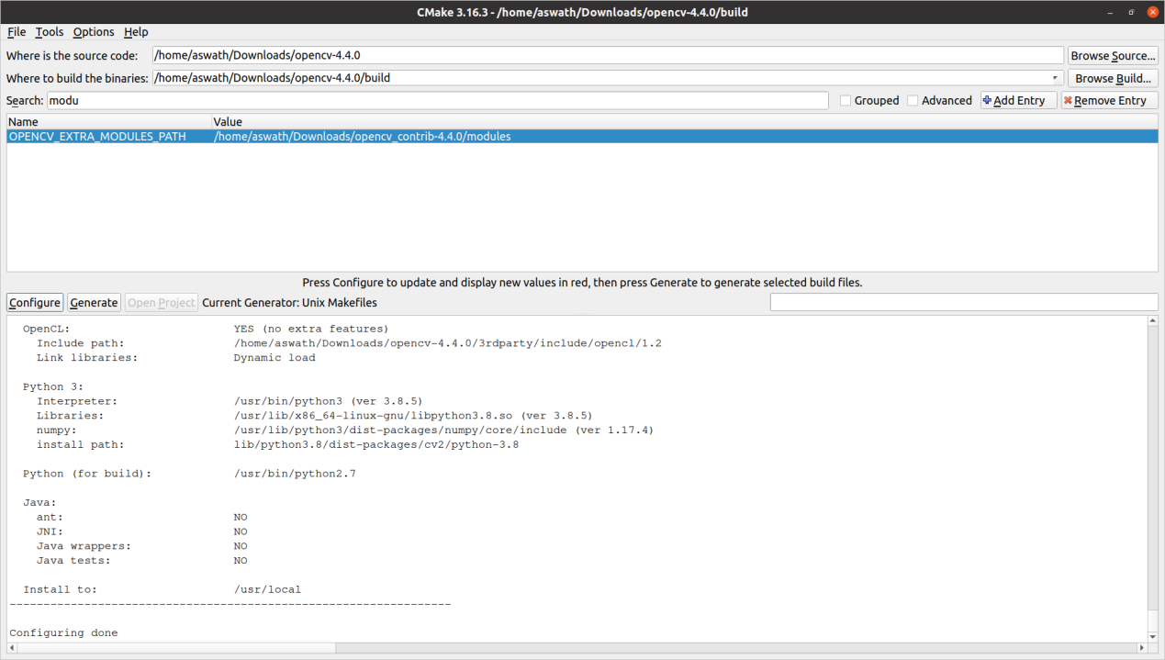

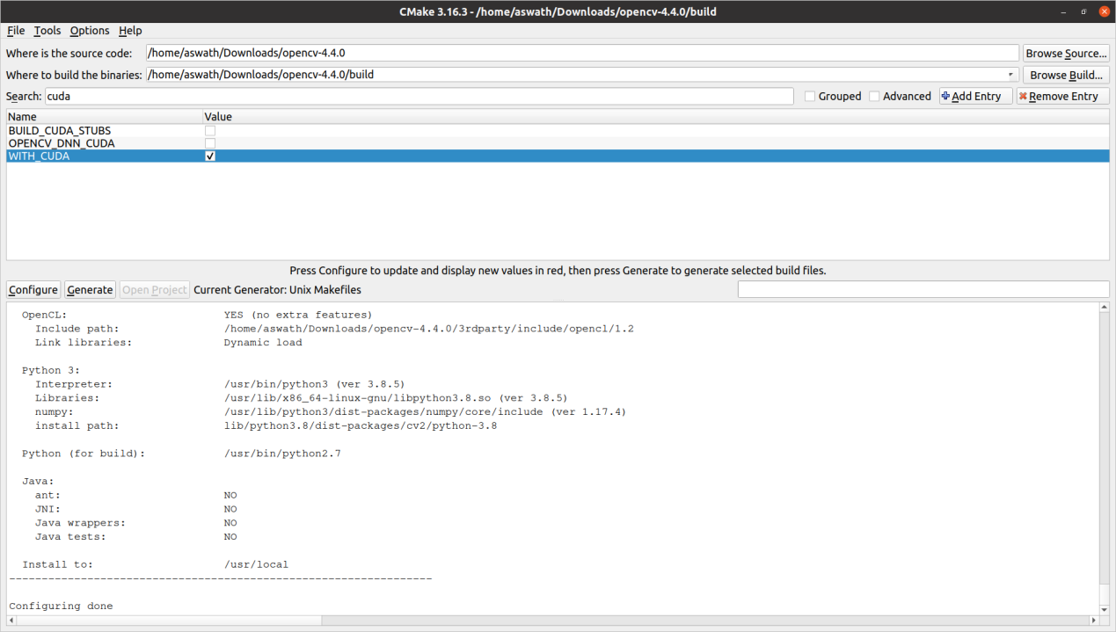

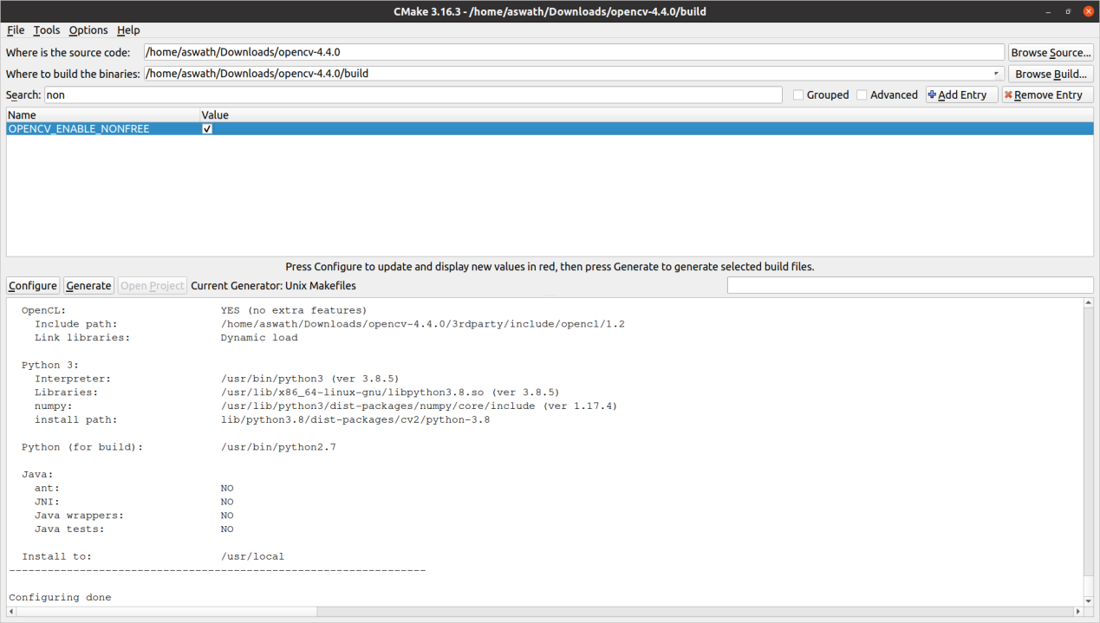

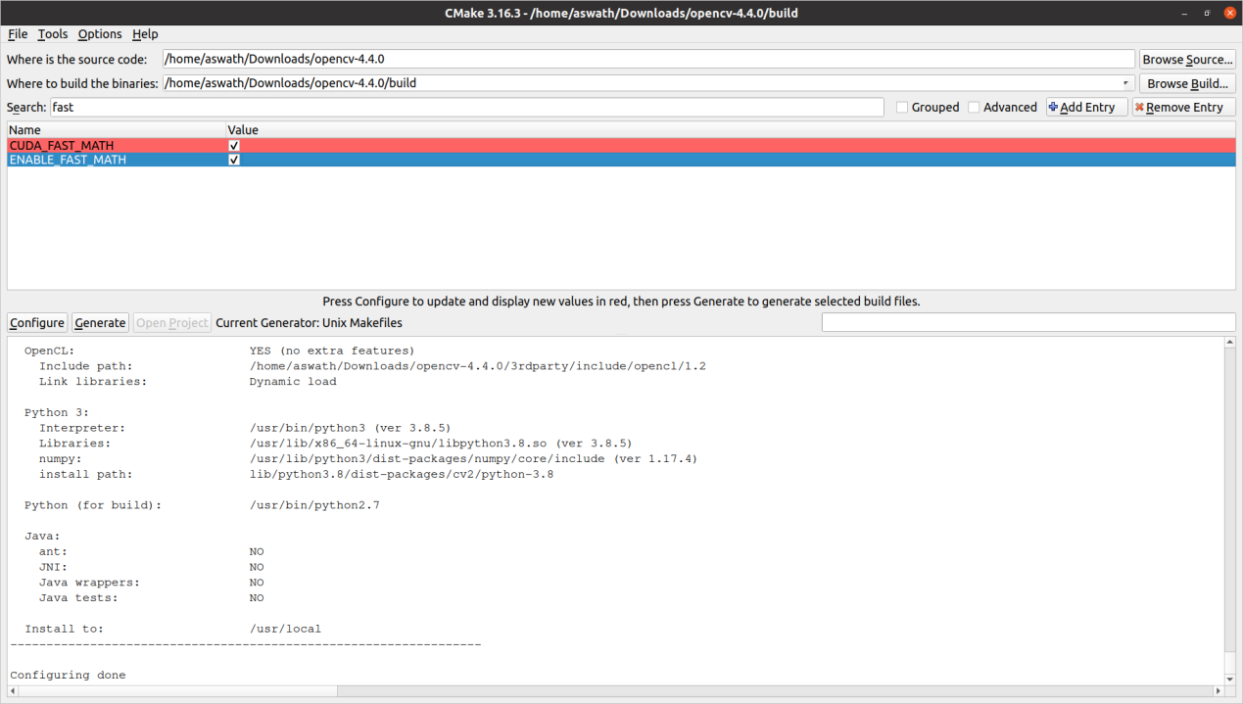

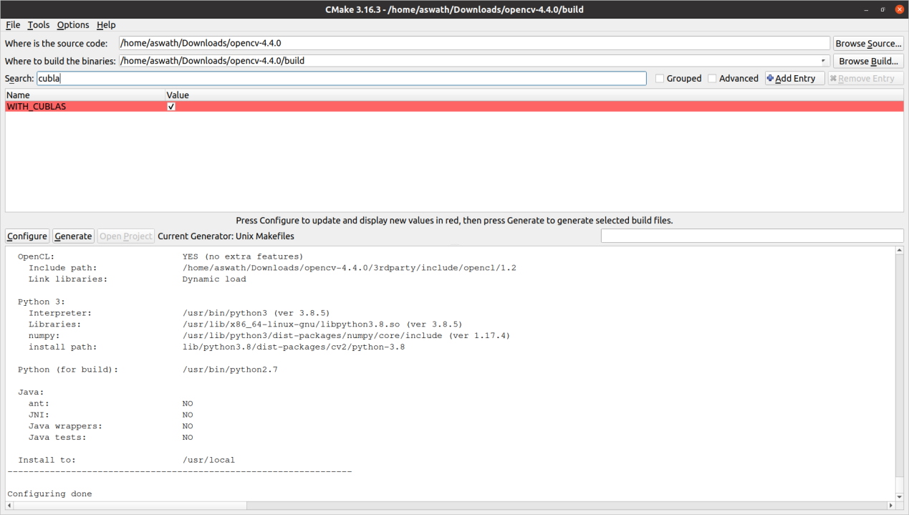

**VERY IMPORTANT:** 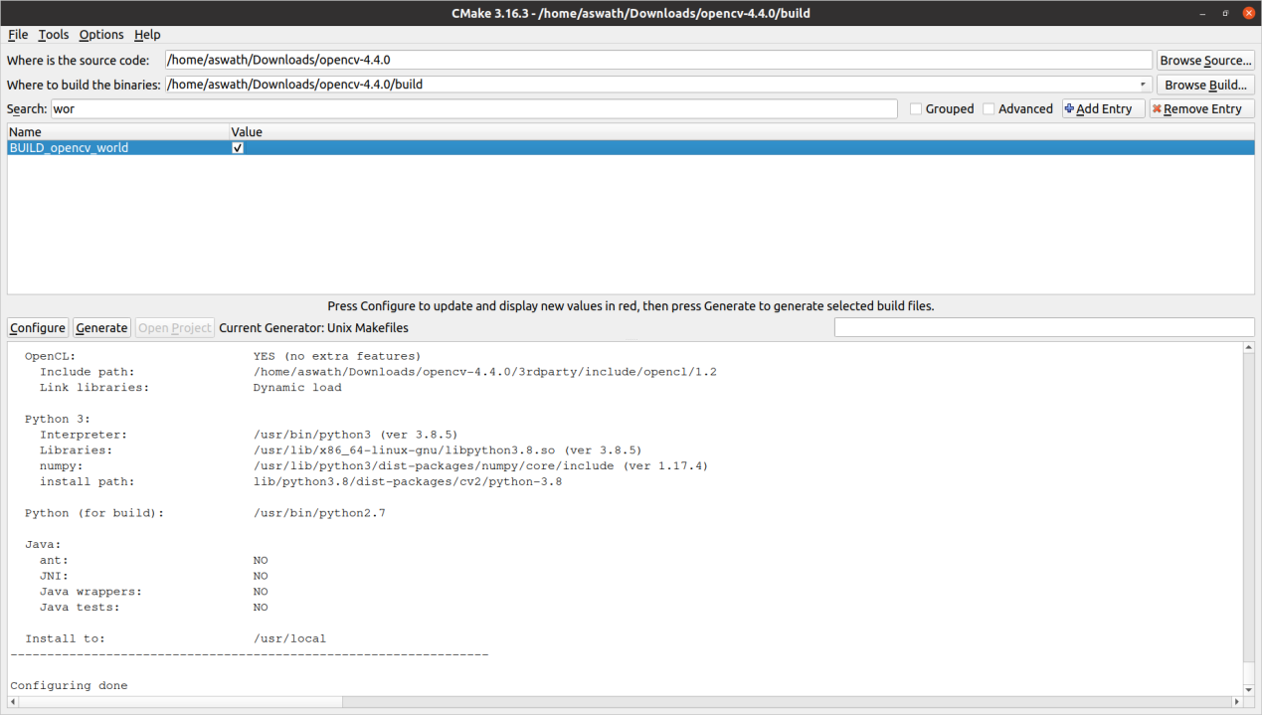

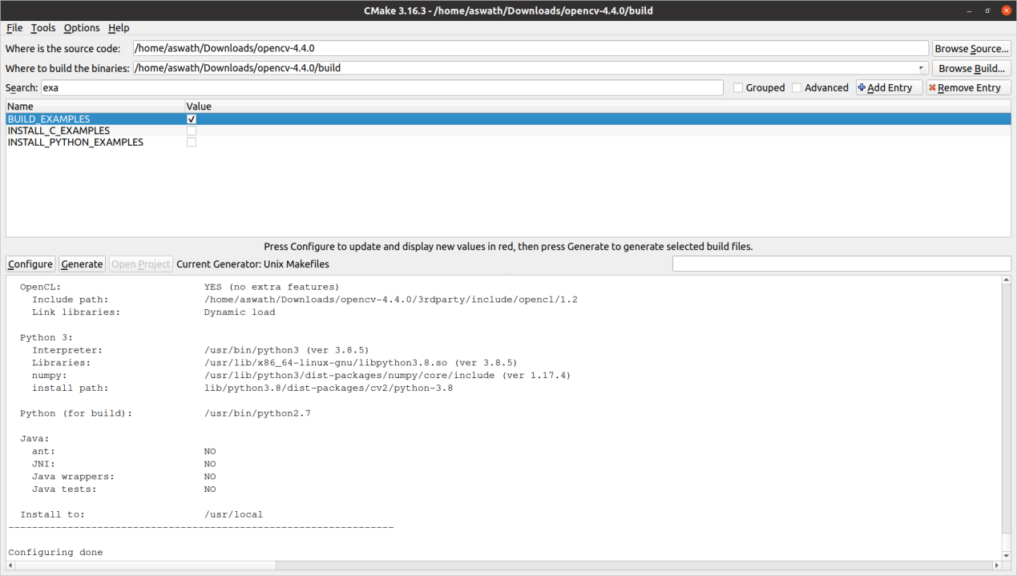

Step 0: Install cuda from the standard repositories. (See [How can I install CUDA on Ubuntu 16.04?](https://askubuntu.com/q/799184/10425))

Step 1: Register an nvidia developer account and [download cudnn here](https://developer.nvidia.com/cudnn) (about 80 MB)

Step 2: Check where your cuda installation is. For the installation from the repository it is /usr/lib/... and /usr/include. Otherwise, it will be /usr/local/cuda/ or /usr/local/cuda-<version>. You can check it with which nvcc or ldconfig -p | grep cuda

Step 3: Copy the files:

Repository installation:

$ cd folder/extracted/contents

$ sudo cp -P include/cudnn.h /usr/include

$ sudo cp -P lib64/libcudnn* /usr/lib/x86_64-linux-gnu/

$ sudo chmod a+r /usr/lib/x86_64-linux-gnu/libcudnn*

Runfile installation:

$ cd folder/extracted/contents

$ sudo cp include/cudnn.h /usr/local/cuda/include

$ sudo cp lib64/libcudnn* /usr/local/cuda/lib64

$ sudo chmod a+r /usr/local/cuda/lib64/libcudnn*

**aswath@aswath-ROG-Zephyrus-G15-GA502IV**:**/**$ locate nvcc

/etc/nvcc.profile

/home/aswath/Downloads/opencv-4.4.0/cmake/FindCUDA/run_nvcc.cmake

/home/aswath/Downloads/opencv-4.4.0/modules/dnn/src/cuda4dnn/csl/nvcc_defs.hpp

/home/aswath/anaconda3/envs/rosconda/include/boost/config/compiler/nvcc.hpp

/home/aswath/anaconda3/envs/rosconda/include/boost/predef/compiler/nvcc.h

/home/aswath/anaconda3/envs/rosconda/share/cmake-3.19/Modules/FindCUDA/run_nvcc.cmake

/home/aswath/anaconda3/pkgs/boost-cpp-1.72.0-h9d3c048_4/include/boost/config/compiler/nvcc.hpp

/home/aswath/anaconda3/pkgs/boost-cpp-1.72.0-h9d3c048_4/include/boost/predef/compiler/nvcc.h

/home/aswath/anaconda3/pkgs/cmake-3.19.6-h3020d66_0/share/cmake-3.19/Modules/FindCUDA/run_nvcc.cmake

/usr/bin/nvcc

/usr/include/boost/config/compiler/nvcc.hpp

/usr/include/boost/predef/compiler/nvcc.h

/usr/lib/nvidia-cuda-toolkit/bin/nvcc

/usr/lib/nvidia-cuda-toolkit/bin/nvcc.profile

/usr/share/cmake-3.16/Modules/FindCUDA/run_nvcc.cmake

**aswath@aswath-ROG-Zephyrus-G15-GA502IV**:**/**$ dpkg-query -L nvidia-cuda-toolkit

/.

/etc

/etc/nvcc.profile

/usr

/usr/bin

/usr/bin/bin2c

/usr/bin/cuda-memcheck

/usr/bin/cudafe++

/usr/bin/cuobjdump

/usr/bin/fatbinary

/usr/bin/gpu-library-advisor

/usr/bin/nvcc

/usr/bin/nvdisasm

/usr/bin/nvlink

/usr/bin/nvprune

/usr/bin/ptxas

/usr/include

/usr/include/nvvm.h

/usr/lib

/usr/lib/cuda

/usr/lib/cuda/bin

/usr/lib/cuda/include

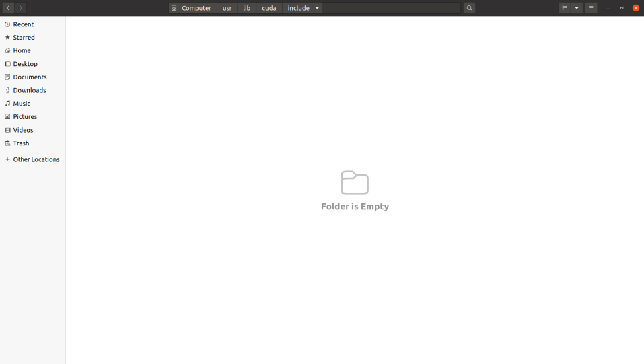

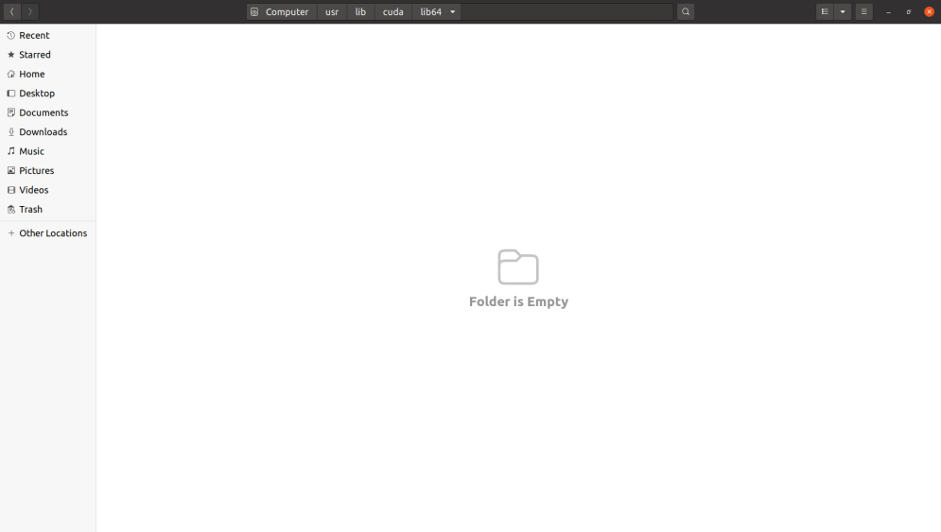

**aswath@aswath-ROG-Zephyrus-G15-GA502IV**:**~/Downloads/cudnn-10.1-linux-x64-v8.0.5.39**$ sudo cp cuda/include/cudnn*.h /usr/lib/cuda/include

**aswath@aswath-ROG-Zephyrus-G15-GA502IV**:**~/Downloads/cudnn-10.1-linux-x64-v8.0.5.39**$ sudo cp -P cuda/lib64/libcudnn* /usr/lib/cuda/lib64

**aswath@aswath-ROG-Zephyrus-G15-GA502IV**:**~/Downloads/cudnn-10.1-linux-x64-v8.0.5.39**$ sudo chmod a+r /usr/lib/cuda/include/cudnn*.h /usr/lib/cuda/lib64/libcudnn*

VERY Important: 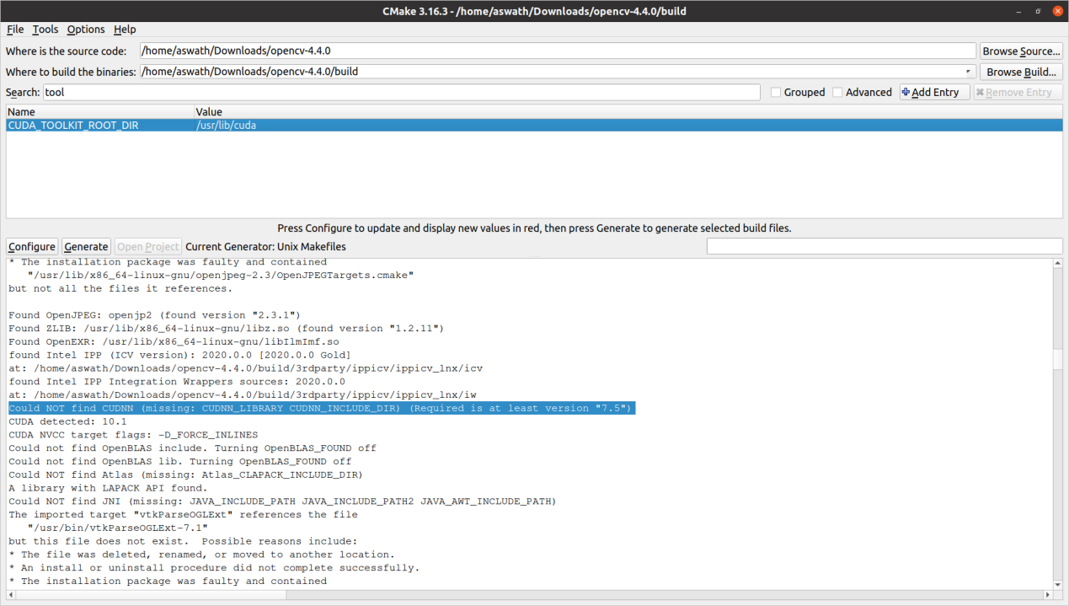

<command-line>: warning: ISO C++11 requires whitespace after the macro name

In file included from /usr/include/cuda_runtime.h:83,

from <command-line>:

/usr/include/crt/host_config.h:138:2: error: #error -- unsupported GNU version! gcc versions later than 8 are not supported!

138 | #error -- unsupported GNU version! gcc versions later than 8 are not supported!

| ^~~~~

CMake Error at cuda_compile_1_generated_add_weighted.cu.o.Release.cmake:220 (message):

Error generating

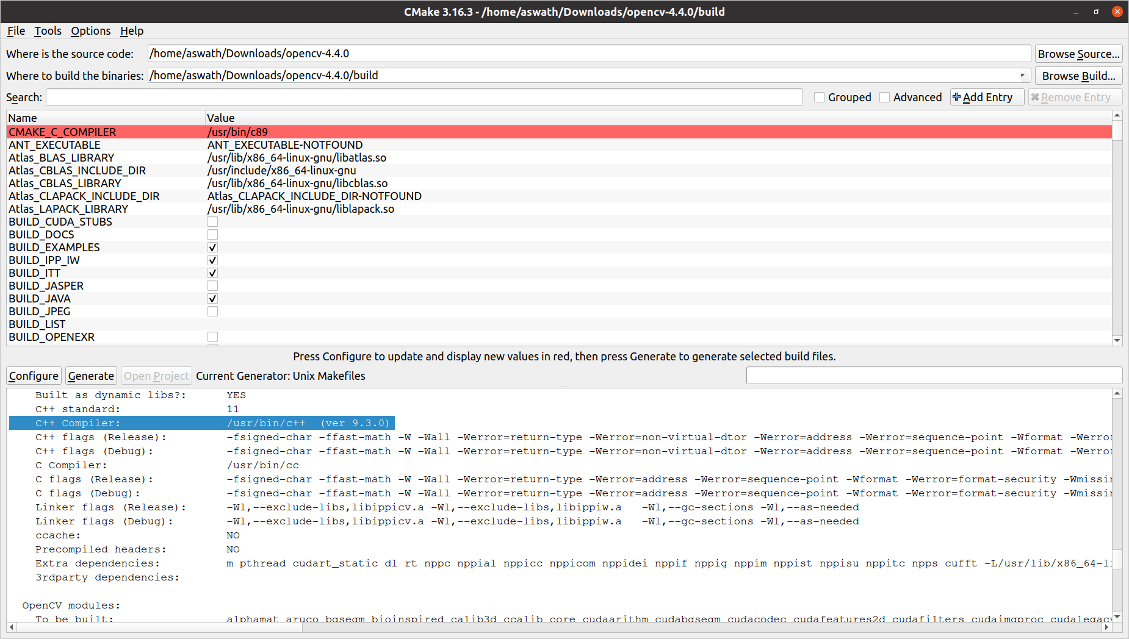

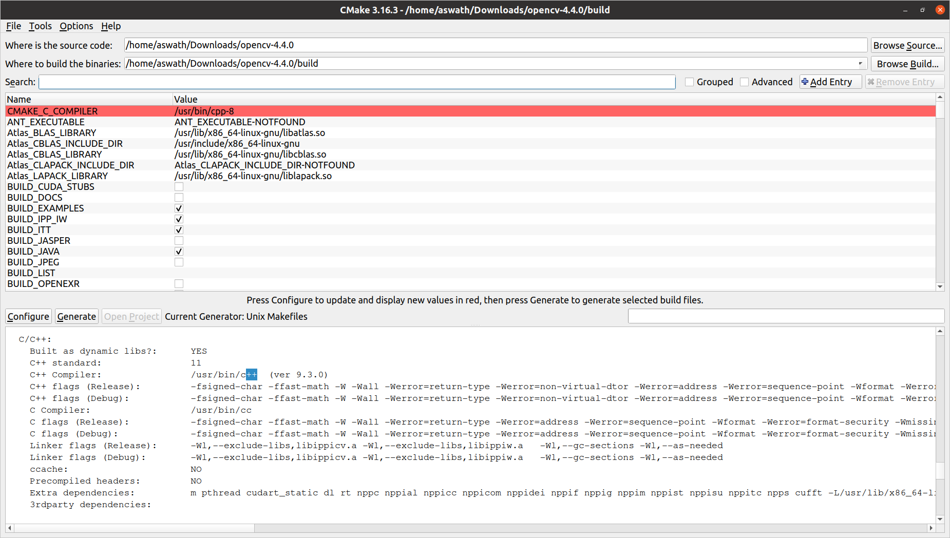

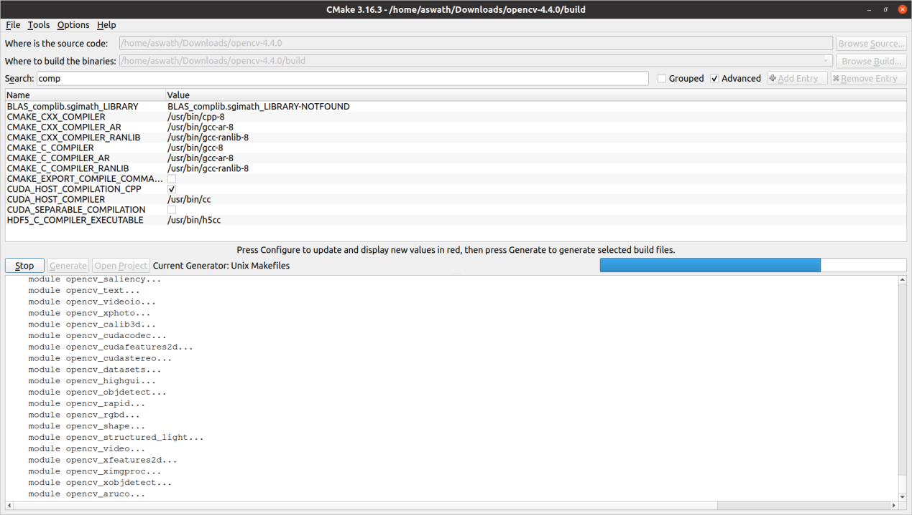

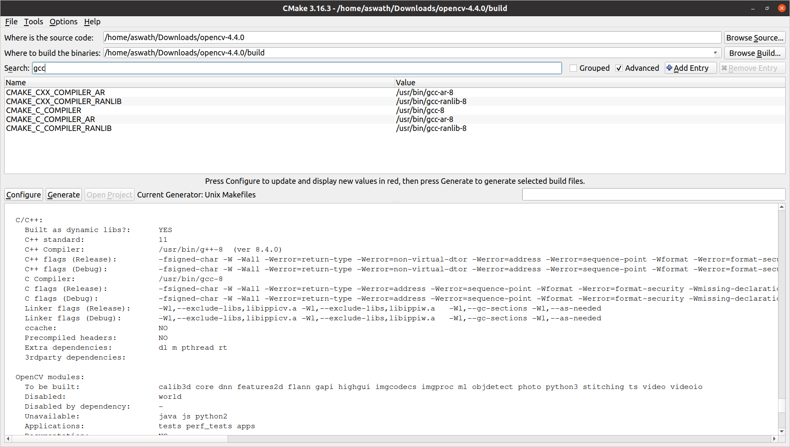

**aswath@aswath-ROG-Zephyrus-G15-GA502IV**:**~/Downloads/opencvTest/build**$ nvprof ./main

==41871== NVPROF is profiling process 41871, command: ./main

Hello world!

==41871== Warning: ERR_NVGPUCTRPERM - The user does not have permission to profile on the target device. See the following link for instructions to enable permissions and get more information: https://developer.nvidia.com/ERR_NVGPUCTRPERM

==41871== Profiling application: ./main

==41871== Profiling result:

No kernels were profiled.

No API activities were profiled.

==41871== Warning: Some profiling data are not recorded. Make sure cudaProfilerStop() or cuProfilerStop() is called before application exit to flush profile data.

**aswath@aswath-ROG-Zephyrus-G15-GA502IV**:**~/Downloads/opencvTest/build**$ sudo nvprof ./main

[sudo] password for aswath:

==41914== NVPROF is profiling process 41914, command: ./main

Hello world!

==41914== Profiling application: ./main

==41914== Profiling result:

Type Time(%) Time Calls Avg Min Max Name

GPU activities: 48.21% 315.53us 1 315.53us 315.53us 315.53us [CUDA memcpy HtoD]

47.23% 309.09us 1 309.09us 309.09us 309.09us [CUDA memcpy DtoH]

4.56% 29.824us 1 29.824us 29.824us 29.824us void cv::cudev::grid_transform_detail::transformSmart<int=4, unsigned char, unsigned char, cv::cudev::ThreshBinaryFunc<unsigned char>, cv::cudev::WithOutMask>(cv::cudev::GlobPtr<unsigned char>, cv::cudev::grid_transform_detail::transformSmart<int=4, unsigned char, unsigned char, cv::cudev::ThreshBinaryFunc<unsigned char, unsigned char>, cv::cudev::WithOutMask>, unsigned char, cv::cudev::ThreshBinaryFunc<unsigned char>, int, int)

API calls: 99.72% 705.17ms 2 352.58ms 203.52us 704.96ms cudaMallocPitch

0.14% 960.05us 2 480.03us 279.58us 680.47us cudaMemcpy2D

0.07% 483.87us 2 241.93us 132.98us 350.89us cudaFree

0.04% 269.94us 97 2.7820us 908ns 72.845us cuDeviceGetAttribute

0.02% 131.30us 1 131.30us 131.30us 131.30us cuDeviceTotalMem

0.01% 69.493us 1 69.493us 69.493us 69.493us cuDeviceGetName

0.01% 42.953us 1 42.953us 42.953us 42.953us cudaLaunchKernel

0.00% 21.512us 1 21.512us 21.512us 21.512us cudaDeviceSynchronize

0.00% 7.0540us 1 7.0540us 7.0540us 7.0540us cuDeviceGetPCIBusId

0.00% 6.2160us 3 2.0720us 1.3970us 3.3520us cuDeviceGetCount

0.00% 2.8630us 1 2.8630us 2.8630us 2.8630us cudaGetDevice

0.00% 2.8620us 2 1.4310us 1.3960us 1.4660us cuDeviceGet

0.00% 1.4670us 1 1.4670us 1.4670us 1.4670us cuDeviceGetUuid

0.00% 1.4670us 1 1.4670us 1.4670us 1.4670us cudaGetDeviceCount

0.00% 1.4670us 1 1.4670us 1.4670us 1.4670us cudaGetLastError

ds